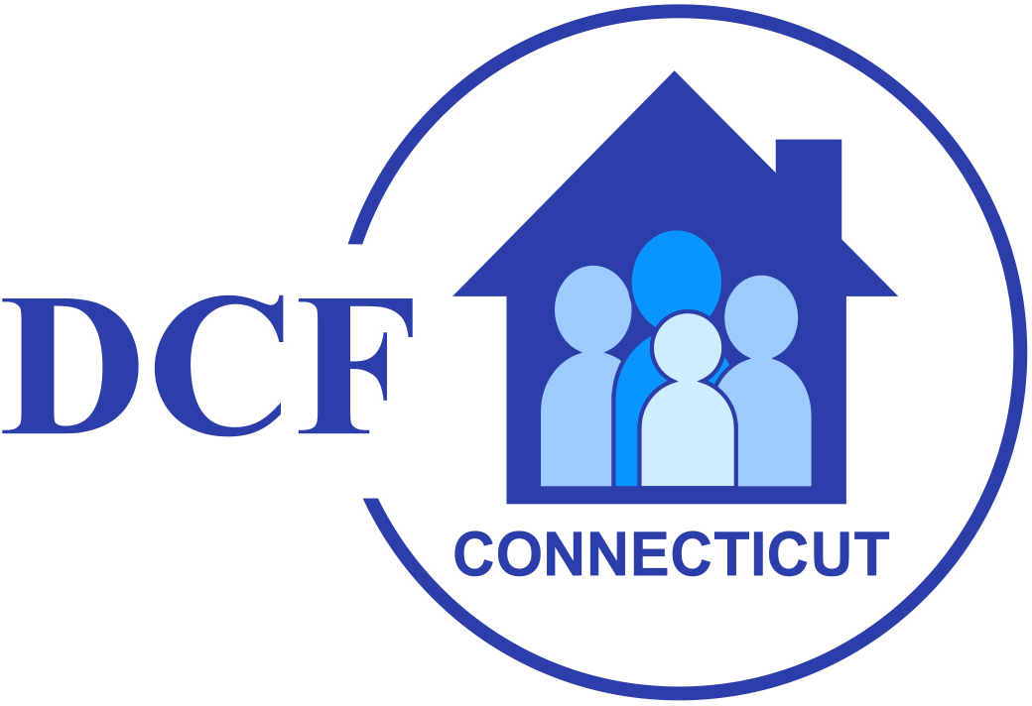
State of Connecticut
Department of Children and Families

Application for Funds Directions

YOUTH SERVICE BUREAU GRANT PROGRAM

July 1, 2021 – June 30, 2023

Purpose: To assist municipalities or private agencies serving youth, which are designated to act as agents for such municipalities, in establishing, maintaining or expanding such Youth Service Bureaus.

Applications Due: (September 1, 2021)

Published: (July 16, 2021)

TABLE OF CONTENTS

I. Purposes and General Information 1
II. Overview 1
III. Who May Apply? 1
IV. Grant Award Period 1
V. Available Funds and Local Match Requirements 2
VI. Required Program Evaluation, Data Collection and Professional Learning Activities 2
VII. Deadline and Use of Application Form 2
VIII. Affirmative Action Assurances 3
IX. Additional Obligations of Grantee 3
X. Due Dates and Ongoing Reporting 3
XI. Freedom of Information Act 3
XII. Management Control of Program/Grant Consultation Role of DCF Personnel……..4
XIII. Annie E. Casey Foundation 4
XIV. Facsimile (Faxed) Copies 4
XV. Technical Assistance 4
XVI. Application Requirements and Format 4
XVII. Directions for Completing Application Form 4
Title Page 4
Section I Youth Service Bureau Profile 5
Section II Administrative Core Unit Strategies and Activities 5
Section III Direct Services Unit Strategies and Activities 6
Section IV Advisory Board Composition Report 7
Section V Impact of Services: Work Plans 8
Section VI Youth Service Bureau Enhancement Grant Application 8
XVIII. Appendices 8
- Certification that a Current Affirmative Action Packet is on File 8
- Statutory Requirement of Administrative Core Unit Functions 8
- Statement of Assurances 8
- Annie E. Casey Foundation 8

Purpose and General Information

The purpose of the Youth Service Bureau (YSB) Grant Program is to assist municipalities and private youth-serving organizations designated to act as agents for municipalities in establishing, maintaining or expanding such YSBs.

II. Overview
Local communities began to develop YSBs in the 1960’s as a response to a growing number of issues affecting youth. The role of the YSBs has been expanded to include both advocacy and coordination of a comprehensive service delivery system for youth. YSBs are organized to provide:
- Administrative services, including an assessment of youth needs and the coordination of services for youth.
- Direct services for youth that may include:
- recreational activities;
- individual and group counseling;
- parent training and family therapy;
- work placement and employment counseling;
- alternative and special educational opportunities;
- outreach programs;
- teen pregnancy services;
- suspension/expulsion services;
- diversion from juvenile justice services;
- preventive programs including youth pregnancy, youth suicide, violence, alcohol and drug use; and
- programs that develop positive youth involvement.
- Administrative core unit functions which include:
- general administration;
- research;
- resource development;
- community involvement; and
- youth advocacy.

Additionally, each YSB is required to have an advisory board responsible for making recommendations on overall policy and program direction of the YSB.

III. Who May Apply?

The list of YSBs eligible for state grants can be located on the Department of Children & Families website at the following link: Youth Service Bureau (ct.gov)

IV. Grant Award Period
The grant award is for the two-year period July 1, 2021, through June 30, 2023. Each grantee must submit an annual budget for approval by the Connecticut State Department of Children and Families (DCF). Funding is contingent on the amount of YSB funds available in each state budget year.

V. Available Funds and Local Match Requirements
Each YSB is eligible for a minimum grant of $14,000. YSBs that received a grant in excess of $15,000 in 1994-95 are eligible for a proportionate share of the remaining appropriation.

Additionally, each municipality must contribute an amount equal to the amount of the state grant, of which no less than 50% of the contribution shall be from funds appropriated by the Municipality. The remaining amount may be matched with other funds or in-kind services. Funding for each State Fiscal Year will be awarded only after the state budget is finalized.

VI. Required Program Evaluation, Data Collection and Professional Learning Activities
Grantees must:
- Participate in the monitoring process, which is a requirement for all new YSB directors. Participants are required to attend all training sessions offered or required by DCF.
- Participate in quarterly meetings, during which DCF will facilitate a review of the progress on the data reporting system and performance measures, to ensure the system and measures are meeting the needs of the grantees, and that children and youth are better off as a result of these accountability efforts.
- Provide accurate and timely reports in such form, in such manner and in such time as prescribed by the Commissioner of DCF regarding the referral or diversion of children and youth from the juvenile justice system, as well as the provision of programs, opportunities and activities for all youth to function as responsible members of their communities.
- Implement the use of the Ohio Scales for youth screening tool.
- Implement Tier 2 service participation surveys.

Pursuant to State Statute, a YSB is required to assess the needs of youth, the availability of services and resources, and development and maintenance of data, in a manner satisfactory to DCF, that is necessary to determine and evaluate the impact of its administrative and services delivery programs. When a YSB collects student data, a consent form executed by the parent or guardian is required. The consent form must contain a statement addressing confidentiality of the information collected.

VII. Deadline and Use of Application Form
The application, IRRESPECTIVE OF POSTMARK DATE AND MEANS OF TRANSMITTAL, must be received by 3:00PM on September 1, 2021. Applications received past the deadline will not be processed without prior written request to and approval of Steven Smith. Applications must be e-mailed to:

e-mail: Stacie Albert - Associate Fiscal Administrative Officer
Connecticut State Department of Children and Families
505 Hudson Street
Hartford, CT 06106
Phone: 860 550-6543
Cell Phone: 860-999-2076
Email: STACIE.ALBERT@CT.GOV

Potential grantees will be required to submit a completed application. The enclosed application form shall be used. Modifications will not be accepted.

VIII. Affirmative Action Assurances
In accordance with the regulations established by the Connecticut Commission on Human Rights and Opportunities (CCHRO), each applicant is required to have a completed/current Affirmative Action Packet or Certification on file with the DCF, or must complete the Affirmative Action Packet by accessing the link (NotificationtoBidderspdf.pdf (ct.gov)) and submit it with this document

IX. Additional Obligations of Grantee
All grantees are hereby notified that the grant to be awarded is subject to contract compliance requirements as set forth in C.G.S. Sections 4a-60 and 4a-60a and Sections 4a-68j et seq. of the Regulations of Connecticut State Agencies (RCSA). Furthermore, the grantee must submit periodic reports of its employment and subcontracting practices in such form, in such manner and in such time as may be prescribed by the CCHRO.

X. Due Dates and Ongoing Reporting
It is the responsibility of all grantees to complete all requirements in the timeframe determined by the DCF. YSBs are required to submit a final report of the data collection by September of every fiscal year. Report due dates are as follows:

FISCAL YEAR | DUE DATE
2021 | August 1, 2021
2022 | August 1, 2022
2023 | August 1, 2023

DCF reserves the right to withhold or reduce funding based on late submission of required reports.

XI. Freedom of Information Act
All of the information provided in a proposal submitted in response to this application for funds is subject to the provisions of the Freedom of Information Act Sections 1-200 et seq., (FOIA). The FOIA declares that except as provided by federal law or state statute, records maintained or kept on file by any public agency (as defined in the statute) are public records and every person has the right to inspect such records and receive a copy of such records.

XII. Management Control of the Program and Grant Consultation Role of DCF Personnel
The grantee must have complete management control of this grant. While DCF staff may be consulted for their expertise, they will not be directly responsible for the selection of sub-grantees or vendors, nor will they be directly involved in the expenditure and payment of funds.

XIII. Annie E. Casey Foundation
Applicants that are part of a collaborative effort funded in whole, or in part, by the Annie E. Casey Foundation must submit documentation to that effect (Appendix D of the Application Requirements).

XIV. Facsimile (Faxed) Copies
Facsimile (faxed) copies of proposals/applications will not be accepted.

XV. Technical Assistance
The DCF Program Manager will be available to answer questions regarding the Request for Proposal application procedures or format.

XVI. Application Requirements and Format
The application must contain the following components:
- Application
- Advisory Board Composition Report
- Budget
- CHRO packet or completed Certification (Included as part of the application)
- Annie E. Casey Foundation documentation

XVII. Directions for Completing Application Form
This Section provides directions for completing Appendix A, Application Form for the YSB Grant.

Title Page
- Legal Name of Organization
For town-based YSBs, report the name of the town that is fiscally responsible for the YSB. For private youth-serving organizations designated to act as agents for one or more towns, report the legal name of the organization.
- Federal Identification Number
Town-based YSBs may leave this line blank. Private youth-serving organizations should report their federal identification number on this line.
- Town(s) to be Served
Town-based YSBs serving a single town should repeat the town name reported on Line 1. YSBs serving more than one town should report all of the towns they serve here. (Abbreviations are allowed as long as it is clear what town is represented by the abbreviations)

- Executive Director
Report the name, phone, fax number and email address of the chief executive officer of the YSB.
- Contact Persons
Report the name(s), phone, fax number and email address(es) of the person(s) to contact with questions and concerns about the YSB program, grant application and annual reports.
- Program Location Address
Report the location of the main business office of the YSB.

Section I - Youth Service Bureau Profile
  - Demographic Information
      - Enter the name of the YSB.
      - Indicate whether the YSB is a municipal department or a nonprofit organization (check one).
      - If the YSB is municipality-based, indicate whether the YSB operates as an independent department or grouped under a larger umbrella structure (check one). If part of a larger structure, enter the name of the department.
      - Enter the total population of the town(s) and the percent of population under age 18. This information is available from the town(s) census.
  - Staffing
      - Provide information on the director of the YSB. Indicate whether the position is full-time or part-time and union or non-union.
      - Provide information on all additional YSB staff.
  - Programming
Place a check next to any of the programs listed that are offered by your YSB.
(This is not intended to be a comprehensive list.)

Section II - Administrative Core Unit Strategies and Activities
Summarize the proposed strategies and activities of your Administrative Core Unit. Group your strategies and activities under the following headings (only one strategy per core unit). Samples will be posted on the DCF website at the following location: Youth Service Bureau (ct.gov)
Examples include:
- Management and Administration – staff recruitment; staff supervision; staff evaluation and development; staff morale and burn-out prevention; filing and implementation regulations; monitoring of subcontractors; maintenance of organizational structure; financial management; casework and clinical supervision; management and information services; board management; marketing; facility management; policy development; strategic planning and development; program development; and decision making.

- Youth Advocacy – voice for youth and youth issues; media relations; speaking at public hearings; contacts with local and state officials; state funding; letter writing; endorsing/creating legislation; networking; proactive trend awareness of youth issues; increasing community awareness of youth needs; and Youth Advisory Board mobilization for advocacy and participation in local, regional and state meetings.

- Resource Development – networking; providing information; fundraising; program development; knowledge of and working with foundations; providing technical assistance; providing consulting to other groups; state funding; professional learning; and state and national awareness.

- Community Involvement – volunteer recruitment; meeting coordination; statewide networking; regional networking; gaining entry into systems; community organization and outreach; board and task force involvement; empowering community organizations; and Youth Advisory Board and promoting youth involvement.

- Research and Evaluation – needs identification and assessment; program evaluation; grant writing; program selection; library/resource file; statistical analysis; college/ university interface; program development; and asset identification/mapping and investigating research models.

Section III - Direct Services Unit Strategies and Activities
Summarize the proposed strategies, programs and tasks of the direct services unit. If subcontractors are used, denote that the services are to be provided by a subcontractor. Note: There may not be strategies and programs for some of these headings. Indicate in the narrative in the tables if there is no programming in certain areas. Samples will be posted on the DCF website at the following link: Youth Service Bureau (ct.gov)
- Juvenile Justice - Services that respond to youth who are, or could potentially be, in contact with the juvenile justice system.
Examples: juvenile review boards; alternative sanction programs; detention/suspension/ expulsion programs; court advocacy; court-ordered community-service programs; truancy programs; and diversion programs.
- Mental Health Services - Services that respond to youth and families who are experiencing emotional distress.
Indicate in write up if the service is for youth (up to 18) or parent/guardian
- Child Welfare - Services to support the development of protective factors to reduce the likelihood, or mitigate impact of, child maltreatment.

- Teen Pregnancy Prevention - Programs that promote pregnancy prevention among young people.
- Teen Parent Education - Services that promote positive parenting skills and support families in their efforts to raise healthy children:
Please indicate in your write up if the program is for teens or adults.

- Positive Youth Development - Programs and services that promote the personal well-being of youth for the purposes of: meeting basic needs; building skills and competencies that allow youth to function and contribute in their daily lives; and connecting youth with their families, peers, schools and communities.
Examples include: peer-to-peer programs; employment training; mentoring; after-school programming; teen centers; dances; adventure based activities; youth adult partnership programs; information dissemination; and prevention programs that address issues such as truancy, violence and substance abuse and drug free alternative activities.

- Community Outreach - Services and activities that support children and youth and strengthen families by reconnecting people of all generations and backgrounds to the community in which they live. This leads to the building of a sense of connectedness and empowerment to bring about positive social change. These are usually one-time events.
Examples include: intergenerational activities; family events; annual events/holiday festivals; sports; dances; family day celebrations; trips; theatrical productions; and cultural activities.

Section IV - Advisory Board Composition Report
A separate document on the Advisory Board must be submitted with the application. Please refer to application document for the Board Composition Criteria. This separate section must address the following components:

- Board Composition - board members need to be identified by category; vacant positions on the board should be identified and described (Item 3 below); and YSBs serving multiple municipalities need to further identify which town each member represents.
- Board Type - Check appropriate box
  - Advisory Board: Refers to a board specifically set up or structured in conjunction with YSB whose sole mission is to serve in an advisory capacity to the YSB
  - Youth Commission: Refers to a commission established by municipal charter which may or may not have been set up in conjunction with YSB but which serves as an Advisory Board to the YSB
  - Other: Refers to any group other than an Advisory Board or Youth Commission serving as an Advisory Board to the YSB (Example: A Board of Directors).
- Vacancies and Waivers - If the Advisory Board has vacancies among its members or if the board is unable to appoint certain representatives, the board does not meet the required size or composition criteria defined in the regulations. A waiver of the requirement(s) may be requested, as well as requesting an extension of time to fill vacancies, but in all cases, the board’s circumstances are to be described in Item 3.
- Full Waiver - A full waiver of the Advisory Board requirements may be granted only where: (1) a YSB has a commission established by municipal charter, or (2) a YSB has a board of directors established by the by-laws of a private organization acting under contract with a municipality, provided that comparable citizen representation is present. A separate written request for a full waiver must be made by the chief municipal official.
- Partial Waiver - A partial waiver may be granted for a board’s size and composition only when the required agencies enumerated in the regulations do not exist in the town or when the regulatory requirements violate a municipal charter (example; town does not maintain a police department). A separate written request for a partial waiver must be made by the executive director of the YSB.
- Extension of Time - An extension of time may be granted for an Advisory Board to recruit and fill temporary vacancies among its members. Specific vacancies need to be identified along with a request for a reasonable length of time in Item 3 of the E section of the grant application.
- Board meetings - Please complete Items a and b.

Section V - Impact of Services: Work Plans
Required Professional Learning Activities: Describe a minimum of three professional development activities planned for YSB staff and community partners, designed to expand knowledge, improve program effectiveness and collaboration. Briefly describe the intended goal of the activity, participants and frequency. Impacted Administrative Core Unit (ACU) Function: Describe intended outcome

Section VI - Youth Service Bureau Enhancement Grant Application
Complete this section if your YSB is also requesting to receive Enhancement Grant dollars.

Appendix A - Certification that current affirmative action packet is on file
Complete this form if you are a municipality that operates a school district and file a federal and/or state Affirmative Action Plan. If this is not the case, submit an Affirmative Action Plan (NotificationtoBidderspdf.pdf (ct.gov)

Appendix B - Statutory Requirement of Administrative Core Unit Functions
Complete the Statement of Statutory Requirement of ACU Functions.

Appendix C - Statement of Assurances
Complete the Statement of Assurances

Appendix D - Annie E. Casey Foundation
Applicants that are part of a collaborative effort funded in whole or in part by the Annie E. Casey Foundation must submit documentation under the following headings:
Collaborative Oversight
The collaborative oversight entity has been provided the opportunity to review and comment on the grant application or proposal prior to submission to the DCF.
Activities
The proposal or application submitted provides information detailing the activities, which assure priority access to services to children, youth and families referred by the collaborative oversight entity.
Liaison
The applicant shall designate someone to act as liaison for the referral process.

