Cardholder Profile =508
1) Click on “Reports”, select “Create”.
2) On Page 2 of the reports menu, click “Cardholder Profile”.
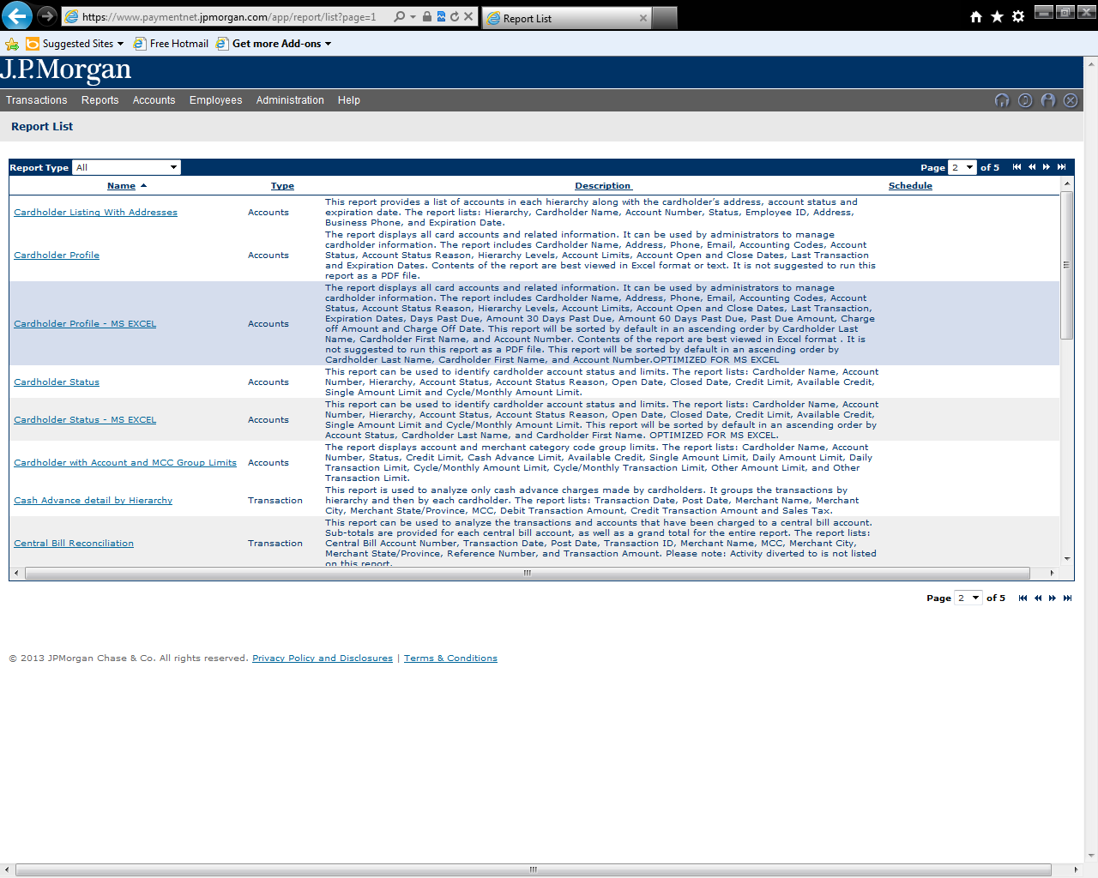
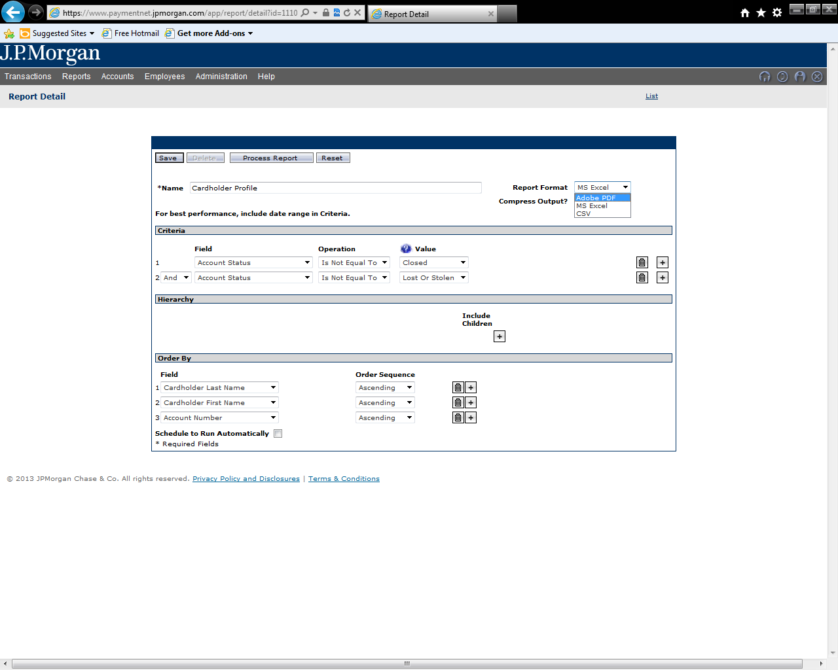
3) Choose a unique name for your report (optional), and select if you want this report to be in Excel or in a PDF.

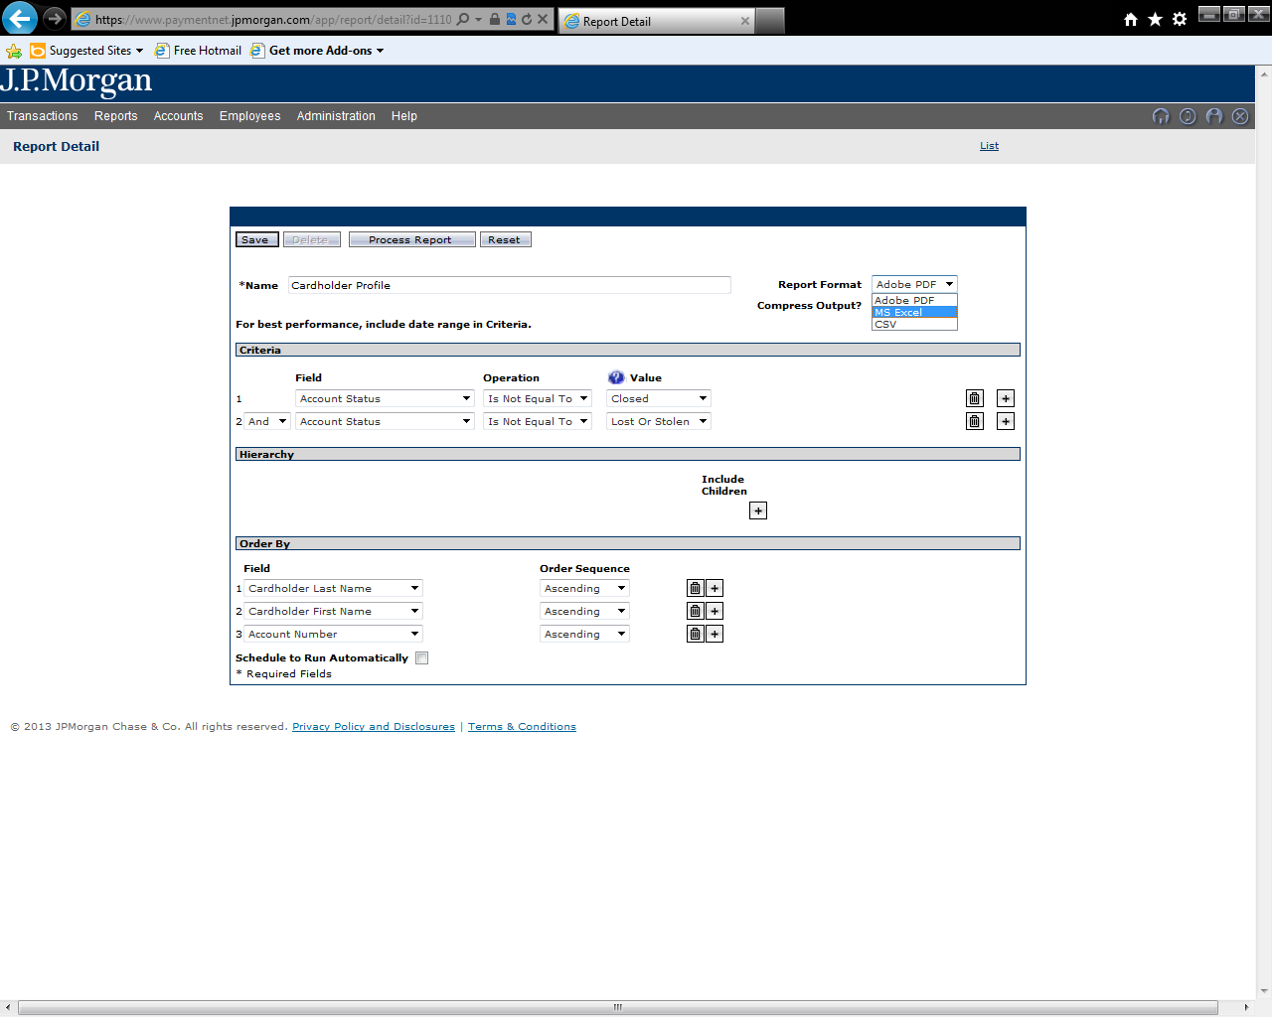

4) Criteria: the default settings of this report will NOT include cards that are closed or have been reported lost/stolen. To include either, in the Criteria section click the “garbage can” icon to the right of the type of Account Status that you want to include.
5) In the Criteria section, click the “+”
6) Click on the “Hierarchy ID” words, then click the “+” next to State of Connecticut and select your agency from the dropdown list.
7) Click the “Include Children” box.
8) Click “Process Report”.
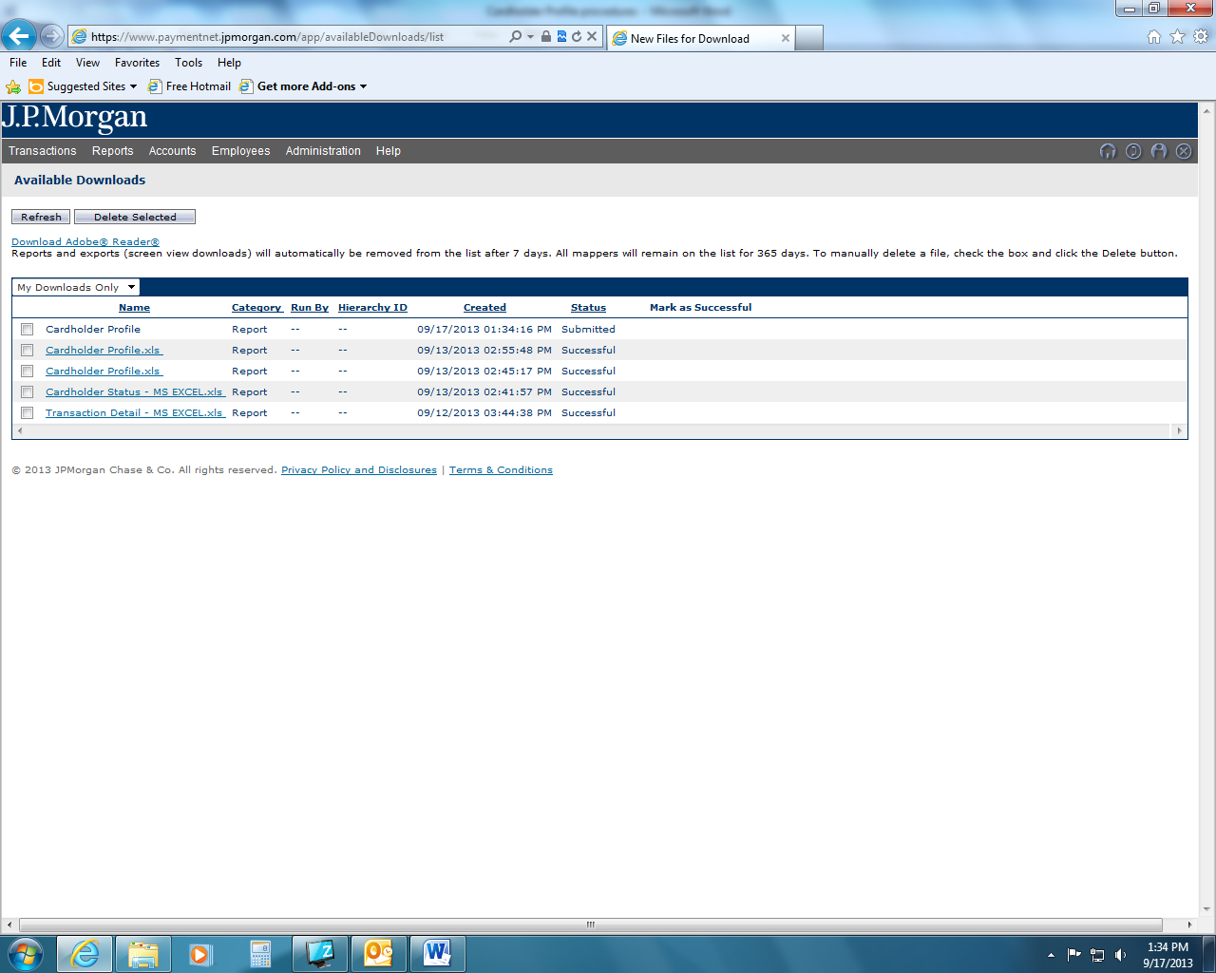
9) This brings you to all reports run recently. Click the report and you can view, download and save your report.
10) If this report was saved as an Excel spreadsheet, you will probably want to delete any of the columns that either are blank or contain information that you do not need.

