To Install the Cisco AnyConnect Client
Follow these instructions to install the Cisco AnyConnect Client. After doing so you can follow the instructions on how to setup your Authentication Method by choosing the proper VPN Guide located here: http://portal.ct.gov/DAS/BEST/Security-Services/MultiFactor-Authentication/Documents

- Obtain the CISCO AnyConnect client install (if not already done) from the VPN Downloads webpage at http://portal.ct.gov/DAS/BEST/Security-Services/Virtual-Private-Network-VPN-Service/Related-Resources to start installation click on the AnyConnect msi provided
  - Cisco AnyConnect version 4.10.07061 is correct, please disregard the screen shot version numbers
- Click on run to proceed with the installation
  - 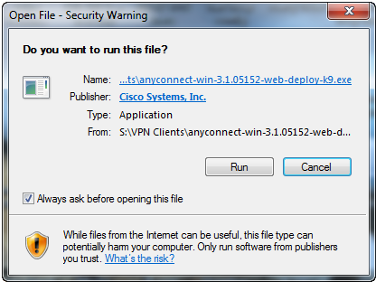

- Click Next to continue
  - 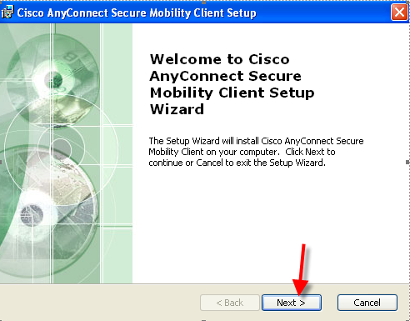
- Click to accept End-User License Agreement. Click Next to continue
  - 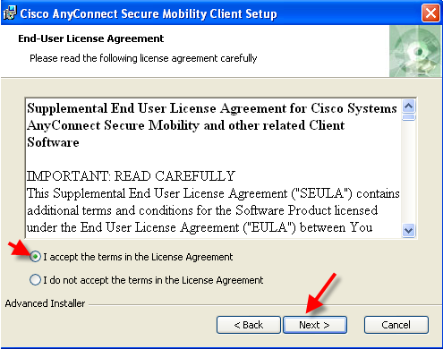
- Click Install to install VPN Client.
  - 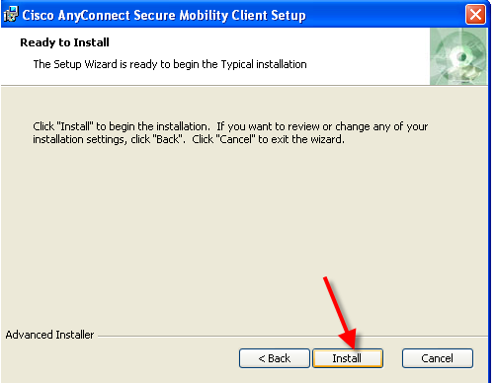

- Install will start
  - 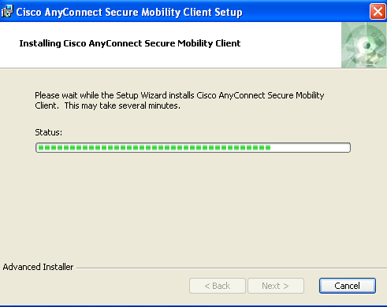
- Click Finish to complete installation
  - 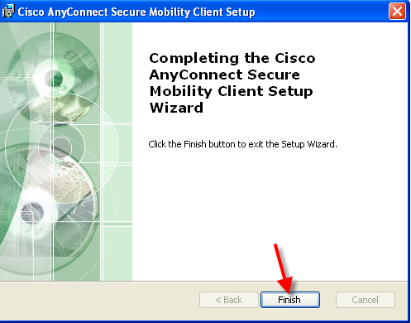
- Installation is complete. You can find the Client by clicking on Start > Type “AnyConnect”, and then select the “Cisco AnyConnect Client”
  - 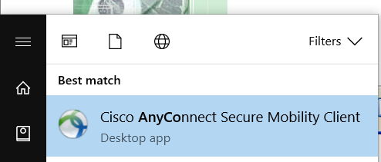

For any questions or concerns please contact your VPN Liaison, or reach out to best.mfaHelpDesk@ct.gov and they will direct you to where you need to go.

