STATE REHABILITATION COUNCIL (SRC)
CT Department of Aging and Disability Services (ADS)
Bureau of Education and Services for the Blind (BESB)
Vocational Rehabilitation (VR) Program

SRC ANNUAL REPORT FY 2020

A. COUNCIL PURPOSE: 1
B. COUNCIL DUTIES: 2
C. COUNCIL ACTIVITIES IN FY 2020: 4
D. MEMBERSHIP: 9
E. BESB VOCATIONAL REHABILITATION HIGHLIGHTS FOR FY 2020: 9
F. FUTURE STATE REHABILITATION COUNCIL ACTIVITIES: 11
G. MEMBERS OF THE STATE REHABILITATION COUNCIL IN FY 2020: 12
H. VOCATIONAL REHABILITATION SUCCESS STORY 15

A. COUNCIL PURPOSE:

The State Rehabilitation Council (the Council or SRC), comprised of individuals appointed by the Governor, works in partnership with, and provides advice to the Department of Aging and Disability Services - Bureau of Education and Services for the Blind (BESB) Vocational Rehabilitation (VR) Program in Connecticut.

BESB serves Connecticut’s adults who are legally blind and current or former transition-age students who are legally blind or visually impaired through ongoing educational, vocational and independent living skills programs in order to empower them to achieve employment success and to enhance their self-sufficiency.

It is the purpose of the Council to advise the Governor of the State of Connecticut and BESB’s VR Program pertaining to the provision of Vocational Rehabilitation Services as described in the Rehabilitation Act of 1973, as amended, to individuals who are blind so that such individuals may prepare for, secure, retain, advance in or regain employment.

B. COUNCIL DUTIES:

The federal law under which the Council was formed, Section 105 of the Rehabilitation Act of 1973, as amended in the Workforce Innovation and Opportunity Act, specifies the functions of the Council. They are:

(1) review, analyze, and advise the designated State unit regarding the performance of the responsibilities of the unit under this title, particularly responsibilities relating to--

(A) eligibility (including order of selection);

(B) the extent, scope, and effectiveness of services provided; and

(C) functions performed by State agencies that affect or that potentially affect the ability of individuals with disabilities in achieving employment outcomes under this title;

(2) in partnership with the designated State unit--

(A) develop, agree to, and review State goals and priorities; and

(B) evaluate the effectiveness of the vocational rehabilitation program and submit reports of progress to the Commissioner of Rehabilitation Services Administration;

(3) advise the designated State agency and the designated State unit regarding activities authorized to be carried out under this title, and assist in the preparation of the State plan and amendments to the plan, applications, reports, needs assessments, and evaluations required by this title;

(4) to the extent feasible, conduct a review and analysis of the effectiveness of, and consumer satisfaction with—

(A) the functions performed by the designated State agency;

(B) vocational rehabilitation services provided by State agencies and other public and private entities responsible for providing vocational rehabilitation services to individuals with disabilities under the Rehabilitation Act; and

(C) employment outcomes achieved by eligible individuals receiving services under this title, including the availability of health and other employment benefits in connection with such employment outcomes;

(5) prepare and submit an annual report to the Governor and the Commissioner of Rehabilitation Services Administration on the status of vocational rehabilitation programs operated within the State, and make the report available to the public;

(6) to avoid duplication of efforts and enhance the number of individuals served, coordinate activities with the activities of other councils within the State, including the Statewide Independent Living Council, the advisory panel established under section 612(a)(21) of the Individual with Disabilities Education Act, the State Developmental Disabilities Planning Council described in section 124 of the Developmental Disabilities Assistance and Bill of Rights Act (42 U.S.C. 6024), the State mental health planning council established under section 1914(a) of the Public Health Service Act, and the State workforce development board and with the activities of entities carrying out the programs under the Assistive Technology Act of 1998;

(7) provide for coordination and the establishment of working relationships between the designated State agency and the Statewide Independent Living Council and centers for independent living within the State; and

(8) perform such other comparable functions, consistent with the purpose of this title, as the State Rehabilitation Council determines to be appropriate, that are comparable to the other functions performed by the Council.

C. COUNCIL ACTIVITIES IN FY 2020:

The State Rehabilitation Council continues to be a valuable and active contributing partner to the Vocational Rehabilitation Program and the Bureau as a whole. Over the course of the past fiscal year the Council members have participated in many activities on behalf of the Bureau, as well as continuing their existing responsibilities as identified in the Rehabilitation Act. These activities included:

State Plan Development:

Considerable time was dedicated to the development of the BESB Vocational Rehabilitation Section of the Unified State Plan for Connecticut. A workgroup was formed to develop goals, objectives and proposed outcomes to bring forth to the full membership of the Council for deliberation. In addition to active involvement in the development of these goals and priorities, the Council further participated in the development and review of the overall plan’s content, providing feedback and recommendations for the numerous sections of the plan. Upon conclusion of this effort, the draft BESB VR section of the Unified State Plan proceeded to a public comment period.

At the conclusion of the public comment period, the SRC convened to review and deliberate on the comments that were received, and collaborated with the Advisory Board for Persons who are Blind or Visually Impaired to obtain their perspective and concurrence with the desired revisions to the draft plan subsequent to the public comment period.

Upon approval by the State Rehabilitation Council, the BESB VR portion of the Unified State Plan was submitted for inclusion into the overall plan for Connecticut’s Workforce System and submitted to Rehabilitation Services Administration, where approval was granted.

Policy Update for Personal Adjustment Training:

Based on a resolution passed by the National Federation of the Blind of Connecticut (NFBCT) pertaining to concerns with the current BESB VR policy on Personal Adjustment Training, the SRC deliberated on the concerns that were encompassed within the resolution. The SRC requested that the State Director present to the Council for their review proposed revisions to the policy that would, if implemented, address and resolve the concerns presented in the NFBCT resolution. At their quarterly meeting in September 2020, the Council reviewed and approved the proposed policy revisions to proceed to a public comment period. The SRC plans to review the public comments at their quarterly meeting in December 2020 and provide their recommendations upon the conclusion of those deliberations.

Public VR 100 Year Anniversary:

In recognition and celebration of the 100th year anniversary of the public vocational rehabilitation program, the SRC members joined with the agency in developing success story profiles, one of which featured a member of the SRC. These success stories were shared with the Council of State Administrators of Vocational Rehabilitation who subsequently distributed them as a part of their national awareness campaign. The success story profiles can be viewed through the following link: Partnerships for Success. One of these success stories is included at the end of this report.

VR Client Achievements Presented at SRC meetings:

During FY 2020, the State Rehabilitation Council continued its initiative for a client of the Vocational Rehabilitation Program to come before the SRC at each quarterly meeting to explain the type of work they are involved in and how BESB services assisted them in achieving their career goals. The SRC members value this component of each meeting agenda as it provides the members with an opportunity to learn directly from clients about the services that can be provided and the successes that result.

Consumer Satisfaction Survey:

The SRC once again commissioned the Center for Public Policy and Social Research (CPPSR) at Central Connecticut State University (CCSU) to conduct the FY 2020 consumer satisfaction survey of Vocational Rehabilitation Program recipients. The purpose of the survey was to evaluate the level of satisfaction with services that clients received from the Vocational Rehabilitation Program at BESB.

Satisfaction with the services received was measured on a 10-point rating scale, with a rating of “10.00” representing the highest level of satisfaction.
The highest mean satisfaction rating was in the category of Personal Care Attendant Services, achieving 9.67. Reader Services achieved the second highest satisfaction rating at 9.0. Higher Education Training Services received a mean satisfaction rating of 8.0. Satisfaction with Rehabilitation and Adaptive Equipment Services earned a mean rating of 7.88, followed closely by Low Vision Services at 7.86. Skills Training Services earned at satisfaction rating of 7.75.
The impact that COVID-19 had on the availability of services was particularly evident in the levels of satisfaction with services that were directly affected by the unprecedented and rapid onset of the pandemic. Small Business Venture Services earned a rating of only 6.20 while Transportation Services earned a rating of only 5.80.
Results from the survey found that 87.5% of clients would recommend BESB services to a friend. The extent to which clients felt that services met their Individualized Plan for Employment goals was rated at 8.08. The extent to which clients felt services met their needs had a mean satisfaction rating of 7.58. Overall satisfaction with BESB services was rated at 7.88.
Despite the challenges that COVID-19 presented, client levels of satisfaction with the services provided by the Vocational Rehabilitation Counselors is particularly noteworthy.
VR Counselor professionalism and VR Counselor ability to provide information in a usable format each achieved a mean satisfaction rating of 8.67. VR Counselor ability to explain Vocational Rehabilitation rights and responsibilities earned a mean rating of 8.30. Knowledge of the VR Counselors was rated at 8.45, and satisfaction with VR Counselor referrals earned a mean rating of 8.03. The Northwestern region showed the highest mean levels of satisfaction with Counselor services, earning a mean rating of 8.80, followed by the Southwest region at 8.51, the North Central region at 8.23, the South Central region at 8.19, and Eastern region at 7.83.

Comprehensive Needs Assessment:

The SRC once again commissioned the Center for Public Policy and Social Research (CPPSR) at Central Connecticut State University (CCSU) to conduct the Comprehensive Needs Assessment that is required to be done every three years. This project will be completed by the end of December 2020. The SRC looks forward to receiving this report and utilizing the information and recommendations to work in partnership with the BESB VR Program to develop goals and strategies that address the needs as identified in the report.

D. MEMBERSHIP:

In FY 2020, appointments to the SRC were made in the categories of Recipients of Services, State Department of Education, Disability Advocacy Group, Statewide Parent Organization, and Employer.

In the coming year, the State Rehabilitation Council will be seeking new members in the categories of Business, Industry, Labor; State Workforce Development Board; American Indian Vocational Rehabilitation; Recipients of Services; and Client Assistance Program.

E. BESB VOCATIONAL REHABILITATION HIGHLIGHTS FOR FY 2020:

The Vocational Rehabilitation Program responded rapidly to the pandemic crisis. Within days of events unfolding in March 2020, a successful transition to teleworking for the Program staff was in place, due in great part to the timing of a technology refresh initiative at the Department level that was completed several months before the pandemic. This new, portable technology made it possible for staff to access the case management system securely and remotely and to coordinate virtual meetings, trainings and services.

Unfortunately, the pandemic brought broad economic implications, reducing employment and training opportunities for clients over a significant portion of the fiscal year. While staff were diligent in their efforts to identify virtual employment and training options, there were far fewer available than what would have otherwise existed in a typical fiscal year. The SRC wishes to acknowledge the creativity of the BESB VR staff in confronting these challenges and for the achievements highlighted below.

- Average hourly earnings reached $23.34, compared to $18.33 in the prior year for the 56 individuals who achieved employment outcomes in FY 2020. Annualized, these earnings exceeded $2.0 million.

- With the rapid development and implementation of virtual services, 44 virtual opportunities were secured for transition-age youth served by the BESB VR Program, including 27 work-based learning experiences and 17 paid work experiences.

- Collaboration with the five Regional Workforce Development Boards has been a strong focus of the Vocational Rehabilitation Program in FY 2020. Prior to the pandemic, Counselors were co-located on a part-time basis at the American Job Centers. After the onset of the pandemic, many activities were shifted to a virtual model. Counselors performed on-site activities on more than 130 occasions and participated in a combination of in-person and virtual business services meetings with American Job Center partners on 65 occasions. Forty-two clients were assisted with registering for services through the American Job Centers.

- Continuing the strong commitment to facilitating clients to be active partners in the career exploration and job seeking process, the Vocational Rehabilitation Program assisted over 100 clients to connect with Career Index Plus, a self-directed web-based resource for researching jobs in demand, credentialing requirements and current job openings.
- Even with the scaling back of many businesses during the pandemic, BESB VR Counselors maintained a strong focus on employer engagement, reaching out to businesses on more than 300 occasions during FY 2020 to explore employment opportunities.

- BESB successfully served all eligible clients in FY 2020 and projects that FY 2021 will also be a year that every eligible client can be served.

F. FUTURE STATE REHABILITATION COUNCIL ACTIVITIES:

In FY 2021, the Council will continue its role as a partner with the BESB Vocational Rehabilitation Program to ensure the delivery of services that afford clients the tools they need to prepare for, obtain, advance in, and maintain meaningful careers. The SRC will work together with the Bureau to support the goals and objectives identified in the Unified State Plan. Of particular importance to the SRC will be active involvement in revising approaches to the effective and safe delivery of services in a pandemic and post-pandemic environment.

The SRC will also deliberate on the Consumer Satisfaction Survey and Comprehensive Needs Assessment reports to assist the Vocational Rehabilitation Program in the development and refinement of strategies to address the recommendations and findings within these two reports.

The Council will look forward to additional research on adaptive technology devices that are new to the market and that can provide for increased participation of Vocational Rehabilitation clients in job seeking activities using web-based search engines.

Additionally, the Council will bring to conclusion their deliberations on proposed changes to the VR policy on Personal Adjustment Training, with the goal of making the policy more effective and beneficial to the clients whom the VR Program serves.

G. MEMBERS OF THE STATE REHABILITATION COUNCIL IN FY 2020:

The Council is committed to seeking appointments of members most qualified to advise the State Director and the Council. The Council is further committed to diversity in gender, race, disability, geography, and affiliation. The Council continuously recruits prospective members who can enhance its diversity. The Council has enjoyed success this year through an active membership, committed to the delivery of quality services to BESB clients.

Per the provisions of the Rehabilitation Act, membership comprises:

- At least one representative of the Statewide Independent Living Council, who must be the chairperson or other designee of the Statewide Independent Living Council

- At least one representative of a parent training and information center established pursuant to section 682(a) of the Individuals with Disabilities Education Act

- At least one representative of the Client Assistance Program, who must be the director of or other individual recommended by the Client Assistance Program

- At least one representative of community rehabilitation program service providers

- Four representatives of business, industry and labor

- At least one qualified vocational rehabilitation counselor with knowledge of and experience with vocational rehabilitation programs who serves as an ex officio, nonvoting member of the Council if employed by the designated State agency

- At least one representative of the State educational agency responsible for the public education of students with disabilities who are eligible to receive services under the Rehabilitation Act and part B of the Individuals with Disabilities Education Act

- The director of the designated State unit as an ex officio, nonvoting member of the Council

- At least one representative of the State Workforce Development Board

- At least one representative of the directors of projects funded under Section 121 of the Rehabilitation Act for American Indian Vocational Rehabilitation Services

- Current or former applicants for, or recipients of, vocational rehabilitation services

- At least one representative of a disability advocacy group representing individuals who are blind

- At least one representative of an individual who is blind, has multiple disabilities, and has difficulty representing himself or herself or is unable due to disabilities to represent himself or herself

The FY 2020 Council members and their affiliations were:

Gary Allen (State Independent Living Council)
Scott Baecker, Treasurer (Community Provider)
Nathaniel Barnes, Secretary (Recipient of Services)
Michael Bartley, Vice-Chair (Business, Industry, Labor)
Brandy Altergott (Employer)
Amanda Billiot (Business, Industry, Labor)
Jay Brown (Department of Education)
John Carnemolla (Recipient of Services)
Alan Gunzburg, Chair (Recipient of Services)
Lucretia Jones (Recipient of Services)
John McNickle (Recipient of Services)
Enaida Mendoza (Vocational Rehabilitation Counselor
Deborah Reed (Disability Advocacy Group)
Beth Reel (Statewide Parent Organization)
Eileen Rose (Recipient of Services)
Dawn Russell (Recipient of Services)
Brian Sigman (BESB State Director)
Kendra Valente (Representative of an Individual who is Blind, has Multiple Disabilities, and has Difficulty Representing Himself or Herself or is Unable due to Disabilities to Represent Himself or Herself)

H. VOCATIONAL REHABILITATION SUCCESS STORY

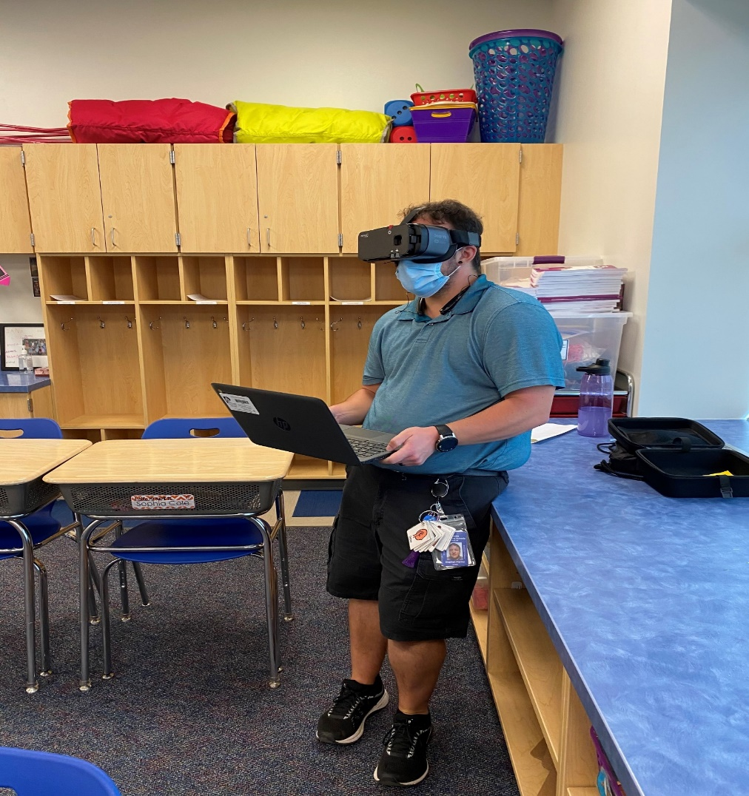

My name is Stephen Marino and I am legally blind. I have received services from BESB since I was a child. Over the years, VR has helped me with education and finding employment as well as all the other needed support services such as mobility, low vision, rehabilitation technology and adaptive technology devices. I currently work as an Intensive Paraprofessional at Frank T Wheeler School, an elementary school in Plainville Community Schools District. I have always used technology to help me see things better. Last summer, I contacted my VR counselor because I was having difficulty reading small print as well as when transitioning to see students faces. VR helped me to identify a wearable device which is essentially like digital binoculars with even more features! The device is called The Patriot Viewpoint. My vocational rehabilitation counselor had me demo it in my summer school assignment and from the second I put it on I knew it was the device that was life changing.

It made me much more confident in my job, as well as during this Covid-19 pandemic and working remotely from home. I worked with students and teachers virtually all day long. We were given Chromebooks which are small and hard to see, but with my Patriot headset I was able to see my screen much easier and see the students' faces on the screen in their small pictures as well as looking at their screens they shared with me with even smaller fonts. I used a mix of Zoomtext and magnification from the computer to see other things when I wanted them to see my whole face or work on a document with them in live time. Overall, this Patriot headset and Zoomtext allowed me to perform my job tasks independently. We used different ways of learning with the technology. It was a different way to teach the students with special needs and learning difficulties virtually. It was very valuable especially with the way technology has improved. The ability to have the firsthand experience of using adaptive technology has been an asset to my job in many ways. While working virtually, I took on a lot more responsibility and helped out the Special Education teacher more than I could have in school and that gave me an opportunity to excel and it showed my ability and all that I have to offer. The virtual classes continued during summer school at which time we were able to begin working with students on the protocol of wearing masks.

Once the town decided to begin school with a hybrid program which consists of in-person classes as well as virtual classes, I was a little anxious and not sure what to expect. Once I got there, I realized the COVID-19 safety protocol was being followed and everyone was wearing their masks and face shields when necessary. All the new rules and guidelines made things more of a challenge, but with adaptive technology it was much easier. I am thankful for my Patriot headset because not only does it enhance what I see but I can be farther away from students and still monitor their activities.

Overall, the services I have received from VR has enhanced my ability to be a professional in my community and maintain employment. I am so thankful beyond words for the support of BESB throughout this pandemic.

