STATE REHABILITATION COUNCIL to the Connecticut Department of Aging and Disability Services - Bureau of Education and Services for the Blind

SRC ANNUAL REPORT FY 2019

A. COUNCIL PURPOSE: 1
B. COUNCIL DUTIES: 2
C. COUNCIL ACTIVITIES IN FY 2019: 4
D. MEMBERSHIP: 9
E. BESB VOCATIONAL REHABILITATION HIGHLIGHTS FOR FY 2019: 10
F. FUTURE STATE REHABILITATION COUNCIL ACTIVITIES: 11
G. MEMBERS OF THE STATE REHABILITATION COUNCIL IN FY 2019: 12
H. VOCATIONAL REHABILITATION SUCCESS STORY 16

A. COUNCIL PURPOSE:

The State Rehabilitation Council (the Council or SRC), comprised of individuals appointed by the Governor, works in partnership with, and provides advice to the Department of Aging and Disability Services - Bureau of Education and Services for the Blind (BESB) Vocational Rehabilitation (VR) Program in Connecticut.

BESB serves Connecticut’s adults who are legally blind and current or former transition-age students who are legally blind or visually impaired through ongoing educational, vocational and independent living skills programs in order to empower them to achieve employment success and to enhance their self-sufficiency.

It is the purpose of the Council to advise the Governor of the State of Connecticut and BESB’s VR Program pertaining to the provision of Vocational Rehabilitation Services as described in the Rehabilitation Act of 1973, as amended, to individuals who are blind so that such individuals may prepare for, secure, retain, advance in or regain employment.

B. COUNCIL DUTIES:

The federal law under which the Council was formed, Section 105 of the Rehabilitation Act of 1973, as amended in the Workforce Innovation and Opportunity Act, specifies the functions of the Council. They are:

(1) review, analyze, and advise the designated State unit regarding the performance of the responsibilities of the unit under this title, particularly responsibilities relating to--

(A) eligibility (including order of selection);

(B) the extent, scope, and effectiveness of services provided; and

(C) functions performed by State agencies that affect or that potentially affect the ability of individuals with disabilities in achieving employment outcomes under this title;

(2) in partnership with the designated State unit--

(A) develop, agree to, and review State goals and priorities; and

(B) evaluate the effectiveness of the vocational rehabilitation program and submit reports of progress to the Commissioner of Rehabilitation Services Administration;

(3) advise the designated State agency and the designated State unit regarding activities authorized to be carried out under this title, and assist in the preparation of the State plan and amendments to the plan, applications, reports, needs assessments, and evaluations required by this title;

(4) to the extent feasible, conduct a review and analysis of the effectiveness of, and consumer satisfaction with—

(A) the functions performed by the designated State agency;

(B) vocational rehabilitation services provided by State agencies and other public and private entities responsible for providing vocational rehabilitation services to individuals with disabilities under the Rehabilitation Act; and

(C) employment outcomes achieved by eligible individuals receiving services under this title, including the availability of health and other employment benefits in connection with such employment outcomes;

(5) prepare and submit an annual report to the Governor and the Commissioner of Rehabilitation Services Administration on the status of vocational rehabilitation programs operated within the State, and make the report available to the public;

(6) to avoid duplication of efforts and enhance the number of individuals served, coordinate activities with the activities of other councils within the State, including the Statewide Independent Living Council, the advisory panel established under section 612(a)(21) of the Individual with Disabilities Education Act, the State Developmental Disabilities Planning Council described in section 124 of the Developmental Disabilities Assistance and Bill of Rights Act (42 U.S.C. 6024), the State mental health planning council established under section 1914(a) of the Public Health Service Act, and the State workforce development board and with the activities of entities carrying out the programs under the Assistive Technology Act of 1998;

(7) provide for coordination and the establishment of working relationships between the designated State agency and the Statewide Independent Living Council and centers for independent living within the State; and

(8) perform such other comparable functions, consistent with the purpose of this title, as the State Rehabilitation Council determines to be appropriate, that are comparable to the other functions performed by the Council.

C. COUNCIL ACTIVITIES IN FY 2019:

The State Rehabilitation Council continues to be a valuable and active contributing partner to the Vocational Rehabilitation Program and the Bureau as a whole. Over the course of the past fiscal year the Council members have participated in many activities on behalf of the Bureau, as well as continuing their existing responsibilities as identified in the Rehabilitation Act. These activities included:

Technology:

To continue with an initiative that started in FY 2017, in FY 2019, vendors of adaptive devices, software and apps were invited to SRC meetings to highlight the capabilities of their products. Demonstrations by OrCam and Be My Eyes were presented at two of the Council’s meetings in FY 2019. The SRC views this as one of their highest priorities to ensure that Council members as well as staff of the Bureau are aware of the vast array of adaptive technologies that are available.

VR Services Handbook:

The SRC recognized that VR policies are extensive and complex. While these policies are required to administer the VR Program, the SRC desired to have a document to provide to clients that was condensed and informational. Toward that end, the SRC participated in a significant redrafting of the prior version of the VR Services Handbook, offering recommendations for wording, outline and format. The VR Services Handbook was subsequently posted on the agency website after revisions were completed. The VR Services Handbook is provided to every client at the time of eligibility.

Order of Selection Workgroup:

As FY 2019 began, the prospects of having to implement an Order of Selection within the next two fiscal years were beginning to appear as a strong possibility. While the cost of purchased services were ebbing downward as a result of policy revisions approved by the SRC subsequent to a public comment period in the prior fiscal year, the costs for administration of the program were increasing, resulting in the overall cost to administer the VR Program exceeding the base annual allotments. Carry forward federal funds were allowing the program to project the capability to cover all costs through FY 2021 but beyond that point was very uncertain.

The Order of Selection Workgroup focused on the methodologies that would be necessary for the implementation of an Order of Selection. A review of the definition of an individual with a most significant disability was undertaken, and recommendations for updating this language was developed. Revisions to the Priority for Services categories were also proposed. Subsequent to a public comment period, the SRC adopted these updates.

In September, the SRC received the welcomed news that the federal reallotment award was $1.4 million, much higher than in the prior two fiscal years. These new funds allowed for a much more optimistic projection of the VR Program’s capacity to serve all eligible individuals beyond FY 2021, easing the urgency for this workgroup to continue for the present time.

Consumer Satisfaction Survey Workgroup:

In FY 2019, the SRC convened a workgroup to review the survey instrument used to obtain client feedback, as well as the process that is used for obtaining survey responses. The survey instrument in use has been relatively constant for the past several fiscal years, with revisions to some of the data collection points, but with little variation in the questions or the methodology for assessing satisfaction ratings. The SRC was particularly concerned that the timing of the survey was contributing to lower than desired response rates. The members believed that having the survey conducted on a quarterly basis rather than annually would result in more clients having a clear and recent recollection of the services they received, therefore making their willingness to participate more likely and their responses to the survey questions more informative. Revisions to the survey process were subsequently implemented, to become effective with the onset of FY 2020. Additional activity for this workgroup will be occurring in FY 2020, including the exploration of web-based surveying options.

Programming and Sponsorships:

The State Rehabilitation Council continued its support for the Youth Leadership Forum (YLF), an annual week-long leadership training program for transition-age youth with disabilities. The SRC is an ongoing co-sponsor of this program and considers both its co-sponsorship and continued funding to be very important and worthwhile.

VR Success Story:

During FY 2019, the State Rehabilitation Council continued its initiative for a client of the Vocational Rehabilitation Program to come before the SRC at each quarterly meeting to explain the type of work they are involved in and how BESB services assisted them in achieving their career goals. The SRC members value this component of each meeting agenda as it provides the members with an opportunity to learn directly from clients about the services that can be provided and the successes that result.

NCSAB / CSAVR 2019 Spring Conference:

The SRC Chairperson attended the National Council of State Agencies for the Blind (NCSAB) and the Council of State Administrators of Vocational Rehabilitation (CSAVR) national conferences in April. The Chairperson attended conference seminars as well as participating in the visit to Washington, DC to meet with Connecticut’s Congressional delegation to educate them on how the Vocational Rehabilitation Program assists people who are blind to achieve employment and self-sufficiency.

Consumer Satisfaction Survey:

The SRC commissioned the Center for Public Policy and Social Research (CPPSR) at Central Connecticut State University (CCSU) to conduct a consumer satisfaction survey of Vocational Rehabilitation Program recipients for FY 2019. The purpose of the survey was to evaluate the services that clients received from the Vocational Rehabilitation Program at BESB.
Results from the survey found that 93% of participants reported that they would recommend BESB VR services to a friend. The most substantial increase in the FY 2019 survey results was in the extent to which clients felt that BESB services met their needs (8.12 out of 10 points, up 0.82 points from FY 2018). The second-largest increase in satisfaction ratings was for overall satisfaction with services (8.22, up 0.67 points from FY 2018), followed closely by the extent to which clients felt services met their IPE employment goal (8.27, up 0.64 points from FY 2018). Satisfaction ratings for counselors increased in all areas surveyed this fiscal year in comparison to the FY 2018 survey.
Three services experienced an increase in mean satisfaction ratings in FY 2019 in comparison to FY 2018. The most sizable increase was for Skills Training Services (9.25 out of 10 points, up 1.5 points from FY 2018). Reader Services achieved a rating of 10.0, up 1.29 points from FY 2018. Personal Care Attendant Services also achieved a satisfaction rating of 10.0 out of 10 points for FY 2019. Higher Education Training achieved a rating of 8.0 out of ten points, up 0.57 points from the FY 2018 survey results. Satisfaction ratings for Rehabilitation and Adaptive Equipment Services came in at 8.41 out of 10 points, consistent with FY 2018. Small Business Services earned a satisfaction rating of 8.5 out of 10 points. Low Vision Services achieved a satisfaction rating of 8.5 points.
Transportation Services earned a lower satisfaction rating in FY 2019, coming in at 6.71 out of 10 points, down 0.86 in mean rating compared to FY 2018. Since transportation services are not directly provided by BESB VR but are instead purchased or coordinated, this rating reflects the overall challenges of securing consistent and reliable transportation options for clients.
In FY 2019, the most significant increase in counselor ratings occurred in relation to their ability to help clients identify career goals (8.78, up 1.92 points from FY 2018). Ratings of counselor professionalism experienced the second largest increase in satisfaction ratings (9.19, up 1.32 points from FY 2018). Counselors’ recognition of clients’ special employment needs also experienced a record high (8.65, up 1.12 points), as did their ability to help clients develop an IPE (8.46, up 1.05 points).

D. MEMBERSHIP:

In FY 2019, appointments were made in the categories of Representative of an Individual who is Blind, has Multiple Disabilities, and has Difficulty Representing Himself or Herself or is Unable due to Disabilities to Represent Himself or Herself, Recipients of Services, and Employers.

In the coming year, the State Rehabilitation Council will be seeking new members in the categories of Business, Industry, Labor; State Workforce Development Board; Native American Vocational Rehabilitation; Disability Advocacy Group; Recipients of Services; Community Rehabilitation Provider; State Education Agency; and Client Assistance Program.

E. BESB VOCATIONAL REHABILITATION HIGHLIGHTS FOR FY 2019:

- Through assistance provided by the Vocational Rehabilitation Program, 87 individuals achieved employment in FY 2019.

- Average hourly earnings for those who achieved employment in FY 2019 was $18.33. Combined annualized earnings exceeded $2.5 million.

- The Social Security Administration provided $154,884 in reimbursement funding to the Vocational Rehabilitation Program for assisting clients of the Program to transition off cash benefits by achieving substantial, gainful employment earning levels.

- Collaboration with the five Regional Workforce Development Boards has been a strong focus of the Vocational Rehabilitation Program in FY 2019. Counselors are co-located on a part-time basis at the American Job Centers. Over 100 clients are registered for services offered through the centers and partner agencies.

- Continuing the strong commitment to facilitating clients to be active partners in the career exploration and job seeking process, the Vocational Rehabilitation Program has assisted 89 clients to register for Career Index Plus, a self-directed web-based resource for researching jobs in demand, credentialing requirements and current job openings.

- More than 60 school-to-work opportunities were provided to transition-age students in FY 2019, including paid work experiences, mentoring matches and skills development programs.

- BESB successfully served all eligible clients in FY 2019 and projects that FY 2020 will also be a year that every eligible client can be served.

F. FUTURE STATE REHABILITATION COUNCIL ACTIVITIES:

In FY 2020, the Council will continue its role as a partner with the BESB Vocational Rehabilitation Program to ensure the delivery of services that afford clients the tools they need to prepare for, obtain, advance in, and maintain meaningful careers. The SRC will work together with the Bureau to support the goals, objectives and timely submission of the BESB portion of the Unified State Plan. Additionally, the members of the Council will assess the results of the 2019 Consumer Satisfaction Survey in detail with a goal of recommending new strategies to address levels of satisfaction that experienced declines from prior years, with a particular emphasis on exploring if untapped transportation resources can be identified and utilized to address the concerns expressed by clients.

The Council will look forward to additional research on adaptive technology devices that are new to the market and that can provide for increased participation of Vocational Rehabilitation clients in job seeking activities using web-based search engines.

Additionally, the Council will explore further revisions to the consumer satisfaction survey instrument and the methodology utilized to collect responses, with a particular focus on modernizing the process through web-based technology.

G. MEMBERS OF THE STATE REHABILITATION COUNCIL IN FY 2019:

The Council is required by federal law to ensure representation of the Bureau’s constituents and employers. It is committed to seeking appointments of members most qualified to advise the State Director and the Council. The Council is further committed to diversity in gender, race, disability, geography, and affiliation. The Council continuously recruits prospective members who can enhance its diversity. The Council has enjoyed success this year through an active membership, committed to the delivery of quality services to BESB clients.

Per the provisions of the Rehabilitation Act, membership comprises:

- At least one representative of the Statewide Independent Living Council, who must be the chairperson or other designee of the Statewide Independent Living Council

- At least one representative of a parent training and information center established pursuant to section 682(a) of the Individuals with Disabilities Education Act

- At least one representative of the Client Assistance Program, who must be the director of or other individual recommended by the Client Assistance Program

- At least one representative of community rehabilitation program service providers

- Four representatives of business, industry and labor

- At least one qualified vocational rehabilitation counselor with knowledge of and experience with vocational rehabilitation programs who serves as an ex officio, nonvoting member of the Council if employed by the designated State agency

- At least one representative of the State educational agency responsible for the public education of students with disabilities who are eligible to receive services under the Rehabilitation Act and part B of the Individuals with Disabilities Education Act

- The director of the designated State unit as an ex officio, nonvoting member of the Council

- At least one representative of the State Workforce Development Board

- At least one representative of the directors of projects funded under Section 121 of the Rehabilitation Act for American Indian Vocational Rehabilitation Services

- Current or former applicants for, or recipients of, vocational rehabilitation services

- At least one representative of a disability advocacy group representing individuals who are blind

- At least one representative of an individual who is blind, has multiple disabilities, and has difficulty representing himself or herself or is unable due to disabilities to represent himself or herself

The FY 2019 Council members and their affiliations were:

Alan Gunzburg, Chair (Recipient of Services)
Michael Bartley, Vice-Chair (Business, Industry, Labor)
Nathaniel Barnes, Secretary (Recipient of Services)
Scott Baecker, Treasurer (Community Provider)
Gary Allen (State Independent Living Council)
Lori Bartolucci (Business, Industry, Labor)
Amanda Jarrell Billiot (Business, Industry, Labor)
Steven Famiglietti (Community Provider)
Colleen Hayles (Department of Education)
Kathleen Marioni (Connecticut Workforce System)
John McNickle (Recipient of Services)
Patrick Melfi (Native American VR Program)
Enaida Mendoza (Vocational Rehabilitation Counselor
Linda Mizzi (Client Assistance Program)
Beth Reel (Statewide Parent Organization)
Eileen Rose (Recipient of Services)
Dawn Russell (Recipient of Services)
Brian Sigman (BESB State Director)
Kimberly Tindall (Disability Advocacy Organization)
Kendra Valente (Representative of an Individual who is Blind, has Multiple Disabilities, and has Difficulty Representing Himself or Herself or is Unable due to Disabilities to Represent Himself or Herself)

H. VOCATIONAL REHABILITATION SUCCESS STORY
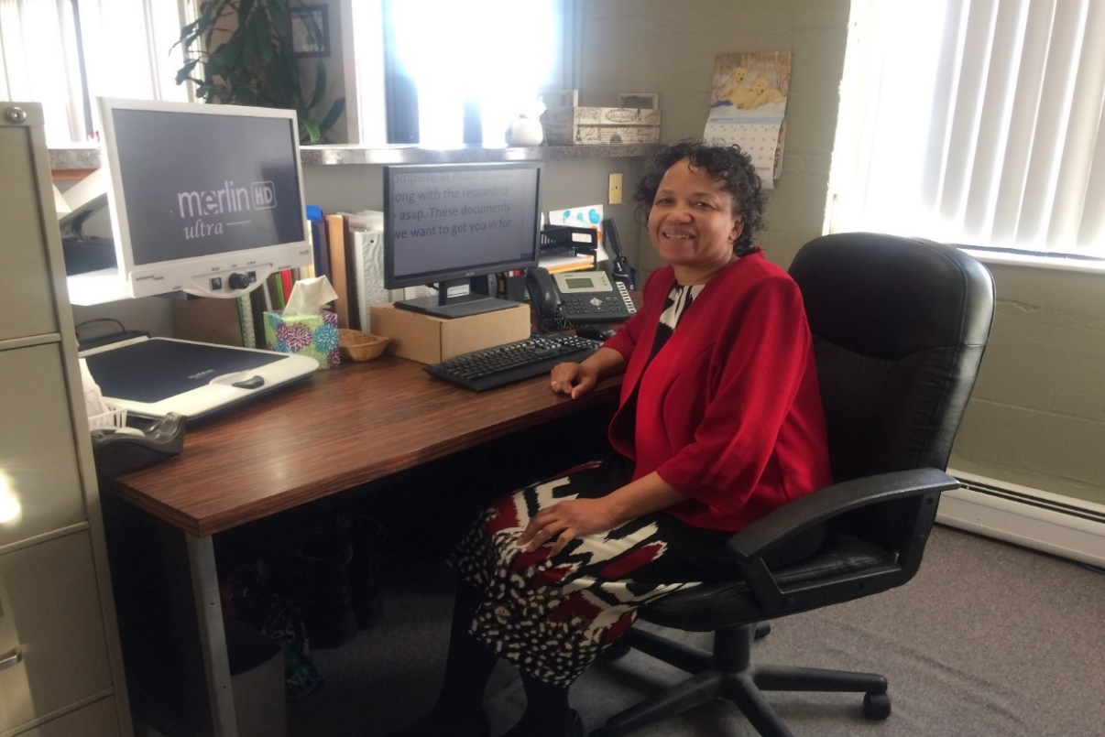

Lucretia was born with Stargardt’s disease. Her eye doctor advised her to contact BESB for assistance, where she became a VR client. A successful volunteer experience led to a paid internship at Neighborhood Housing Services of New Britain (NHSNB). Although there were no employment opportunities available when the internship ended, as a result of the professionalism, work ethic, and enthusiasm she had displayed during her internship and volunteer experience, Lucretia was hired when a position became available and she is now working as a full-time Housing Assistant. The NHSNB Finance Director refers to Lucretia as “Our Person of 1st Impressions!!”, based on her caring, calm demeanor and personable attitude when dealing with clients. Lucretia is very grateful for the services that she has received from BESB VR, which included job placement services, low vision aids, rehabilitation technology, and adaptive equipment which she depends upon to help her successfully perform her job.

