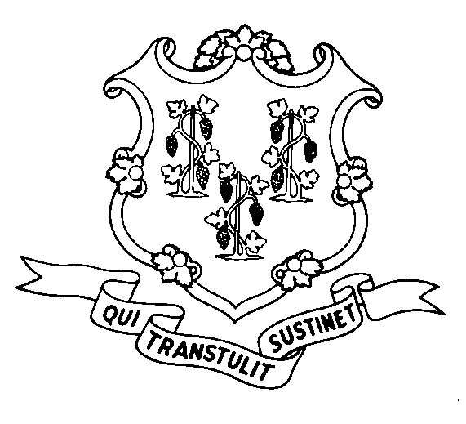
STATE OF CONNECTICUT
DEPARTMENT OF SOCIAL SERVICES
UNIFORM POLICY MANUAL

______________________________________ July 1, 2005
Claudette J. Beaulieu, Deputy Commissioner Effective Date

POLICY TRANSMITTAL NO.: UP-06-12

SUBJECT: Home Delivered Meals

This transmittal revises the maximum daily rate (flat fee) for home delivered meals (Meals on Wheels) under the State Supplement program. The new rate is $4.65 per day for single meal delivery and $8.50 per day for double meal delivery.

INSTRUCTIONS FOR UPDATING THE UPM:

Remove and Recycle Insert

P-4525.10 P-4525.10
DISPOSITION: This Policy Transmittal may be recycled once the UPM has been updated.

DISTRIBUTION: UPM list

RESPONSIBLE UNIT: Adult Support, (860) 424-5250
Date Issued:

SM

25 SIGOURNEY STREET - HARTFORD, CONNECTICUT 06106-5033
An Equal Opportunity / Affirmative Action Employer
Printed on Recycled or Recovered Paper

