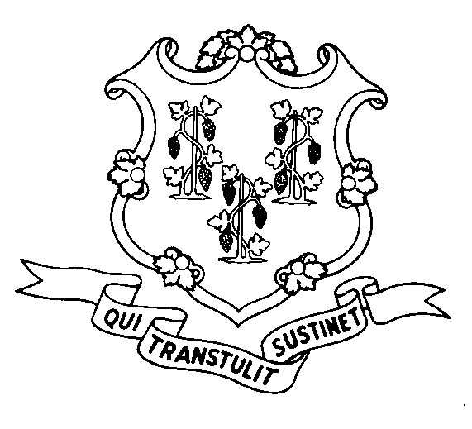
STATE OF CONNECTICUT

DEPARTMENT OF SOCIAL SERVICES

UNIFORM POLICY MANUAL

___________________________________ April 1, 2004
Claudette J. Beaulieu, Deputy Commissioner Effective Date

POLICY TRANSMITTAL NO.: UP-04-03

SUBJECT: Changes to Procedures for Reopening Closed Cases

This transmittal changes the procedures for reopening assistance units that have been recently terminated. It changes the recommended timeframe for reopening closed cases without a new eligibility determination document from three calendar months to six calendar months. It also adds a period of incarceration of less than six months in a correctional institution as a type of short duration discontinuance which should be subjected to the new procedures

INSTRUCTIONS FOR UPDATING THE UPM:

Remove and Recycle Insert

P-1505.10 page 1 P-1505.10 page 1
P-1505.10 page 2 P-1505.10 page 2

DISPOSITION: This policy transmittal may be recycled once the UPM has been updated.

DISTRIBUTION: UPM list

RESPONSIBLE UNIT: Adult Support Unit – Telephone (860) 424-5250

Date Issued:

LRC
An Equal Opportunity / Affirmative Action Employer
Printed on Recycled or Recovered Paper

