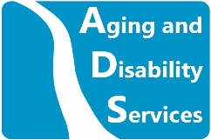
Department of Aging and Disability Services (ADS) is committed to high quality service. You can help us to improve our service by answering the questions on this comment card. Please answer these questions based on your own experience with Aging and Disability Services.
- How did you find out about us?
- Are you aware of the services offered by Aging and Disability Services? Yes No
Comments:
- Was the behavior of Aging and Disability Services staff professional and courteous? Yes No Comments:
- If you could change one thing about your most recent interaction with Aging and Disability Services what would it be?
- Were you connected to the services and/or supports you needed? Yes No
Comments:
- Did you find our response time reasonable? Yes No
Comments:
- What did Aging and Disability Services do well?
Further Comments and Suggestions:
Name (optional):

